PABLO PICASSO
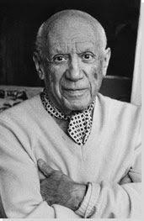 | 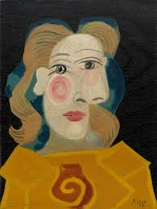 | 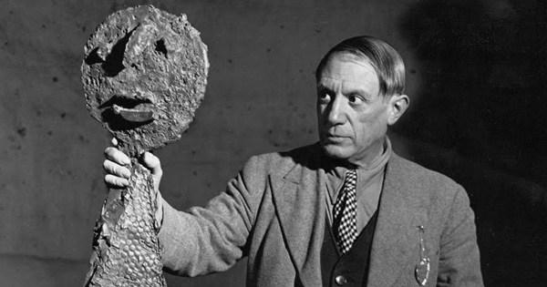

1 Pablo Picasso was an artist. He is famous for inventing new and very different ways to paint. Picasso was born on October 25, 1881, in Malaga, Spain. (1) His father was also an artist. When he was young, Picasso studied art with his father and at art schools in Malaga and then in Barcelona. In 1897, he went to the Royal Academy in Madrid, but left and went home to Barcelona.
2 In Barcelona, he became part of a group of artists and writers. Picasso began to travel to Paris in 1900 to meet and work with other young artists. _________________________ After 1904, he lived in France most of the time.
3 During his long life, Picasso painted in many different ways. From 1901 to 1904, he did most of his paintings in blue. (2) This is called his Blue Period. From 1904 to 1906, he used mostly red and pink, which is called his Pink Period.
4 In 1907, he invented a new kind of painting called cubism. He painted people and objects as geometrical forms, such as cubes. At first, most people did not like (3) this new type of painting, but it slowly became more popular. In 1937, Picasso painted Guernica, one of his most famous cubist paintings. _______________ It is now considered to be a masterpiece.
5 Picasso worked on many other new types of paintings, but he was also a sculptor and a designer. In 1917, he designed the set and the costumes for a ballet. ___________________ In the 1940s, he wrote a play and two books of poetry. Picasso was very poor when he was a young artist, but he became wealthy and very famous. He was married twice and had four children. He died at age 91 in Antibes, France, on April 8, 1973.

Part A: Match the headings in COLUMN A with the paragraphs in COLUMN B.

COLUMN A | COLUMN B
PARAGRAPH 1 | a. His new kind of invention on painting
PARAGRAPH 2 | b. His past occupations
PARAGRAPH 3 | c. His school life
PARAGRAPH 4 | d. His awards and certificates
PARAGRAPH 5 | e. Colorful periods in his painting life
 | f. How his travelling life started

Part B :Read the text very carefully and put the events in order.

a. He painted most of his paintings in blue. ( )
b. He wrote a play and two books of poetry. ( )
c. He designed the set and the costumes for a ballet. ( )
d. He lived in France most of the time. ( )
e. He invented a new kind of painting called Cubism. ( )
f. He went to a Royal Academy. ( )
g. He painted his masterpiece, Guernica. ( )
h. He began to travel to Paris. ( )

Part C: Read the questions and choose the correct option.

- As an artist, Pablo Picasso is famous for __________________.
a. designing costumes.
b. inventing new ways of painting.
c. organizing colorful shows.
d. writing poetry books.

2. He began to spend a lot of time in France because ________________.
a. he had to look after his father.
b. his school was there.
c. he met and worked with other young artists there.
d. he met his wife in Paris.

- According to the text, which information is TRUE about cubism?
- Cubism is a new kind of sculpture.
- Cubism became very popular as soon as it appeared.
- People and objects are in geometrical forms in Cubism.
- There were two periods in Picasso’s Cubism; Blue and Pink Periods.

- Find the word in paragraph 4 means ‘create or make something new’ ______________
- Find the word in paragraph 4 means ‘a piece of art done with very great skill’ _______
- Find the word in paragraph 5 means ‘rich ’ _________________________

PART D: Read the sentences below and find where they could be inserted in the passage. Mark them on the passage on page 1.
a. The painting became a symbol of anti-war activism because it was connected to social and political causes.

b. This period was the beginning of his journey into art movements such as Blue Period and Pink Period.

c. This work let Picasso mix the world of performing arts with his interesting style.

PART E: Read each statement below. Place a “T” if you think the statement is TRUE. Place an “F” if you think the statement is FALSE.

T/F
1. He studied art with his father.
2. He had three important periods, Blue, Red and Pink.
3. People liked his cubism style, and it became popular.
4. He was born poor, but he died rich.

